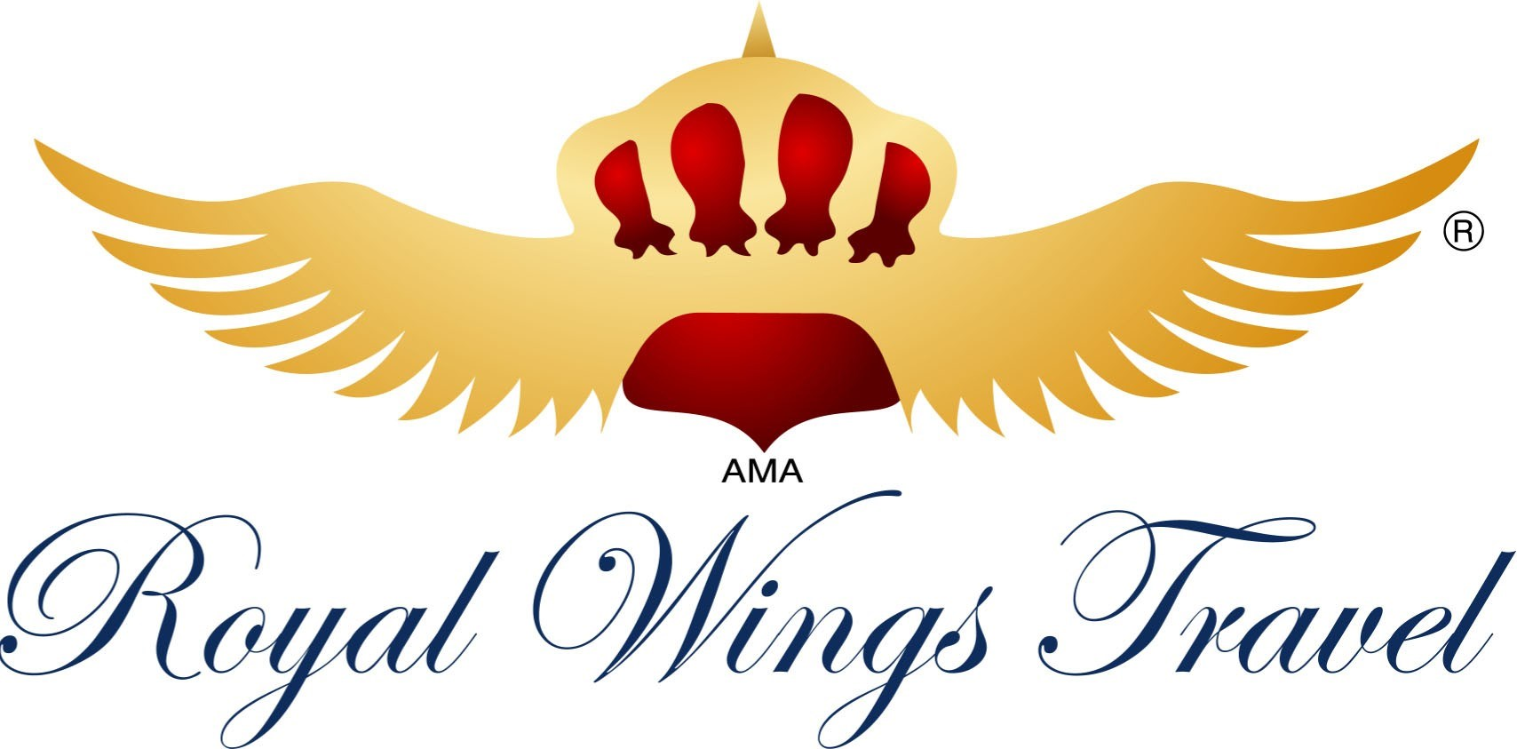 | CREDIT CARD AUTHORIZATION FORM
Note: A copy of Front and Back of Credit Card, as well as a picture ID, must be sent
Please fill out form and fax it back to our fax number: 303 337 7584
Record Locator (confirmation Number): ………………………………………………………………………….
 I …………………………..…………………….. Authorize ROYAL WINGS TRAVEL to charge my
Credit Card for the purchase of (specify numbers) …………………………………… Airline Ticket(s) as follow:
From: …………… To: …………… To: …………… Date: ……………
- Credit Card Type: ……………………………………….……………………………………….………
- Credit Card Number: ……………………………….……………………………………………………
- Expiration Date: ……………………………………………….…………………………………………
- Amount of Charge: $ …..…….…… Per adult, $………….……. Per child $ ……………… Per infant Total: $………….…
- Name of Passenger(s): …..………………….….…………………………………………………………
……..………………………………………….………….………………………………………………
- Credit Card Billing Address:
Street: ………………………………………………………………………………………………………..
City: …………………………………………………………………………………………………………
Tel. number: ………………………………… Alternate Tel. Number ………………………………….…  Mailing Address for Tickets:
Street: ………………………………………………………………………………………………………..
City: …………………………………………………………………………………………………………
Tel. number: ………………………………… Alternate Tel. Number …………..……..……………….…
- E-mail Address for Electronic Tickets:
……………………………………………………………….…….
…………………………..…… …………………………..…… …………………………..……
Card Holder’s Signature Card Holder’s Name Date

By signing above, I agree to pay the above amount for my ticket(s), purchase, and I agree to Royal Wings Travel’s fare rules and restrictions; including non-refundable clauses and/ or applicable cancellation fees.
If you are a travel agent, you accept full responsibility for charge-backs, disputes and other nonpayment(s) by the passenger, credit card holder, credit card Company of issuing bank. Please stamp the form with agency stamp and fax it back to us.

1979 S HAVANA ST • AURORA/ COLORADO • 80014 PHONE: 303 337 1234 •FAX: 303 337 7584

